|  |  |
| --- | --- |
|  | **Qatar University**  **College of Engineering**  **Department of Computer Science and Engineering** |

**Mobile Application**

**L-51**

**Project Phase 1: YalaPay**

**Project Group Members:**

**Hanan Rashid – 202006354**

**Rain Alkai – 202005090**

**Arwa Alobeid-202102413**

**Hanan Alyafei - 201808914**

* **Contribution:**

In our group project, Hanan Alyafei made a great early contribution by focusing on the login and customer use cases. She did push her work once done, following updates with the group and communicating with Hanan Rashid, in particular, to add any updates or corrections to the code. Hanan Alyafei updates prompted Hanan Rashid to integrate these changes into the codebase actively. This collaborative effort enhanced Hanan Rashid's workload and ensured that the implementation was aligned with the latest design requirements.

Rain also played a key role, working on the report and manage cheque features. Her work was exceptional and greatly enhanced our project.

Hanan Rashid tackled the dashboard and invoices use cases, bringing valuable insights and functionality to the team. Later, Arwa began working on the report invoice and payment use cases. However, she faced some challenges with her UI, which led Hanan Rashid and Rain to step in and complete the tasks for usecase arwa was working on. Their collaboration helped ensure that the majority of the project was finished successfully.

Both Hanan Rashid and Rain demonstrated remarkable dedication and hard work during this phase. They collaborated closely and troubleshooting issues. Their ability to quickly adapt and take on additional responsibilities was essential in keeping the project on track.

Overall, the teamwork and adaptability demonstrated by Hanan Alyafie, Rain, and Hanan Rashid were instrumental in pushing the project forward and overcoming obstacles.

**Contributions Percentage:**

|  |  |  |
| --- | --- | --- |
| **Hanan Rashid** |  | **32.5** |
| **Rain Alkai** |  | **32.5** |
| **Hanan Alyafei** |  | **20** |
| **Arwa** |  | **15** |

* **Figma:**

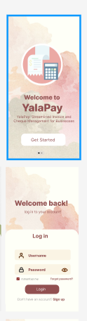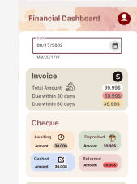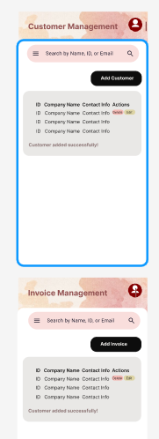

* **UI Screenshots:**
* 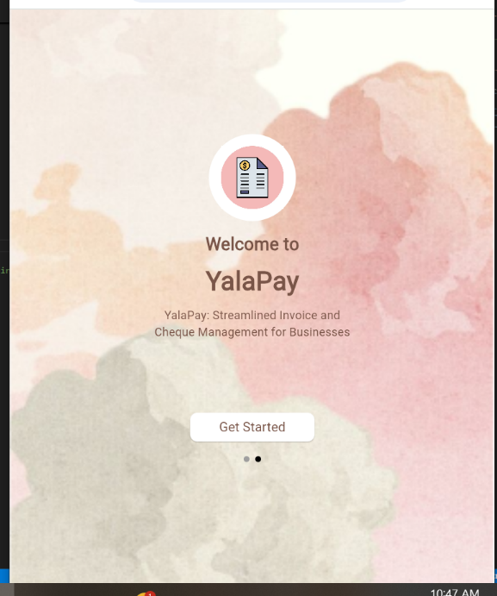**Start screen:**
* **Login**:

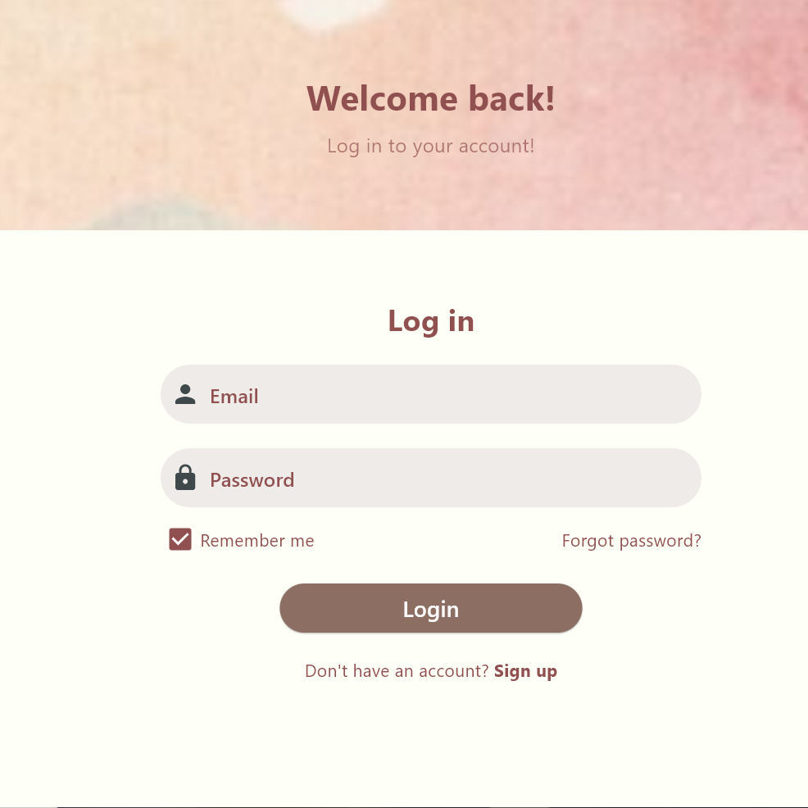

* **Incorrect validation**

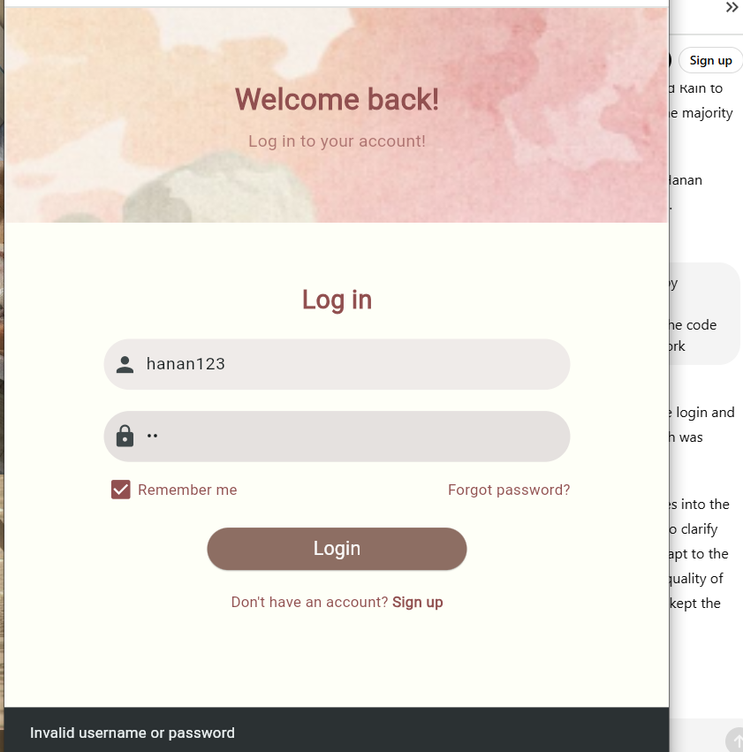

* **Correct Validation**

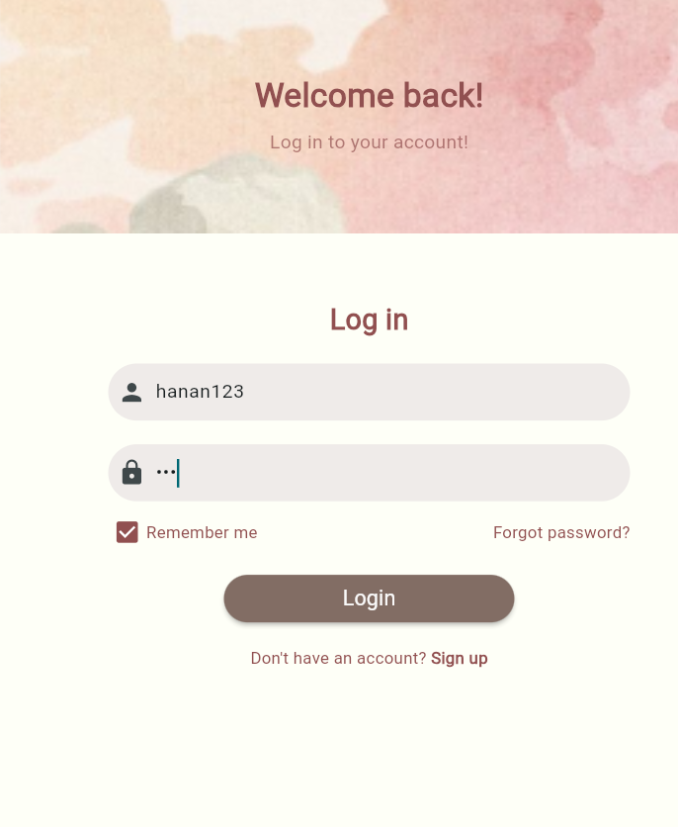

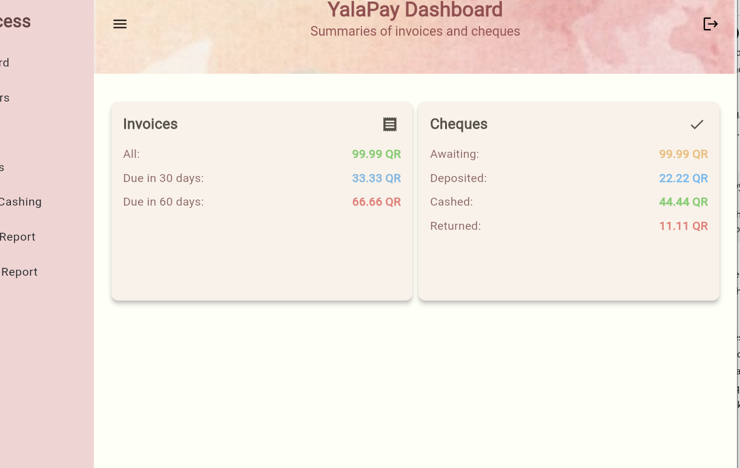

* **Logout**

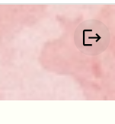

* **Dashboard (Responsive):**

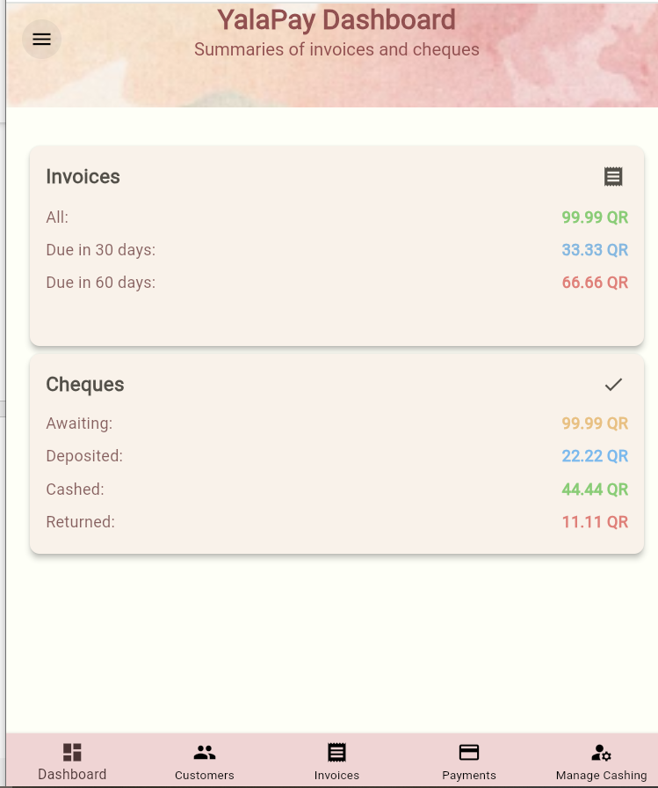

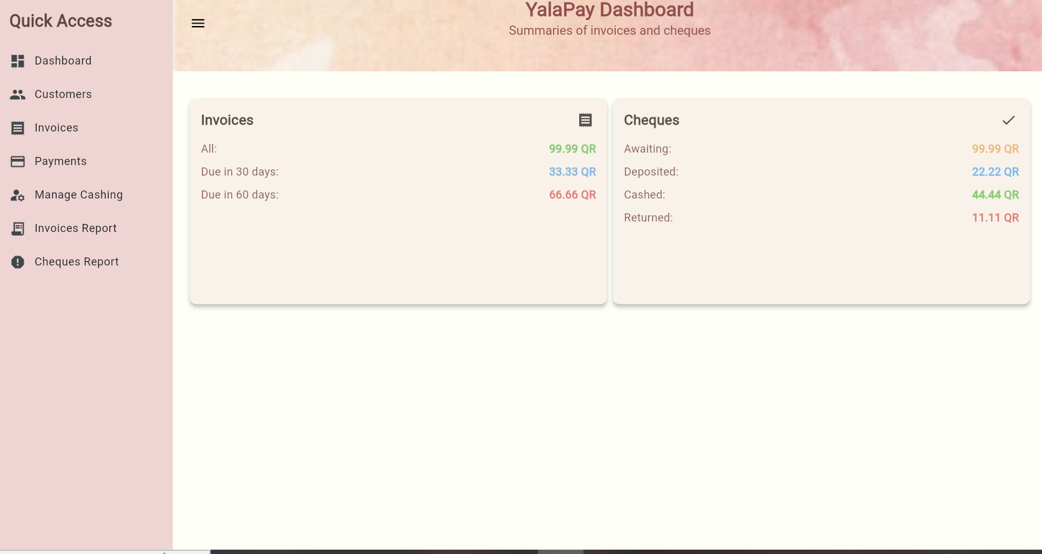

* 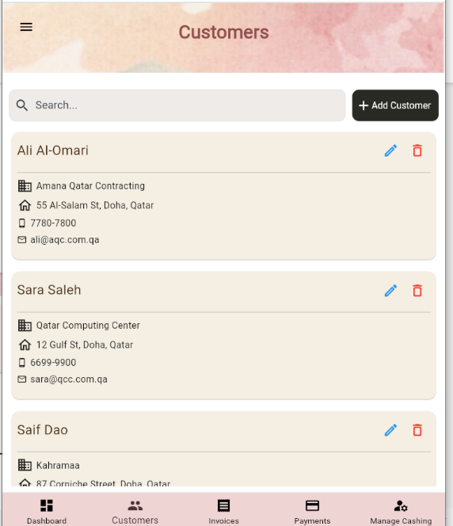**Customers (Responsive) :**
* **Customer Delete:** 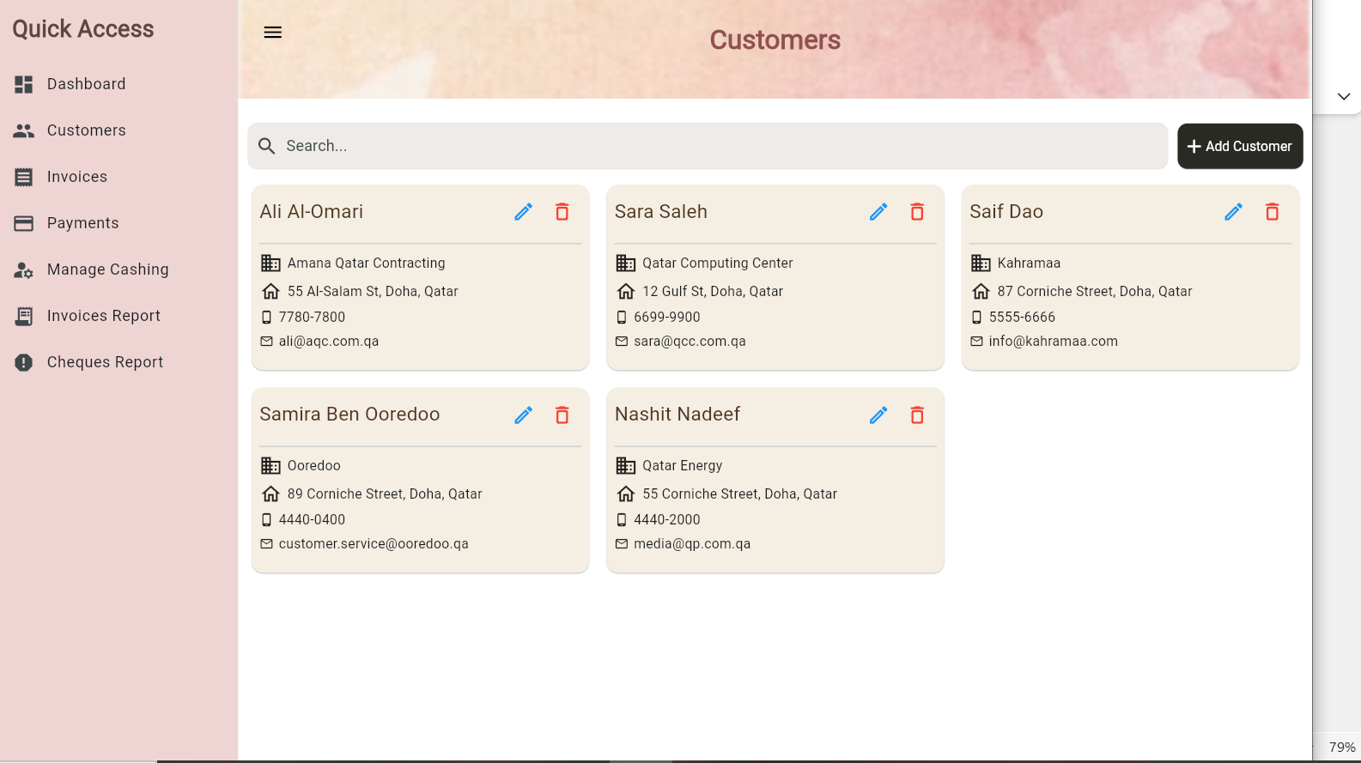

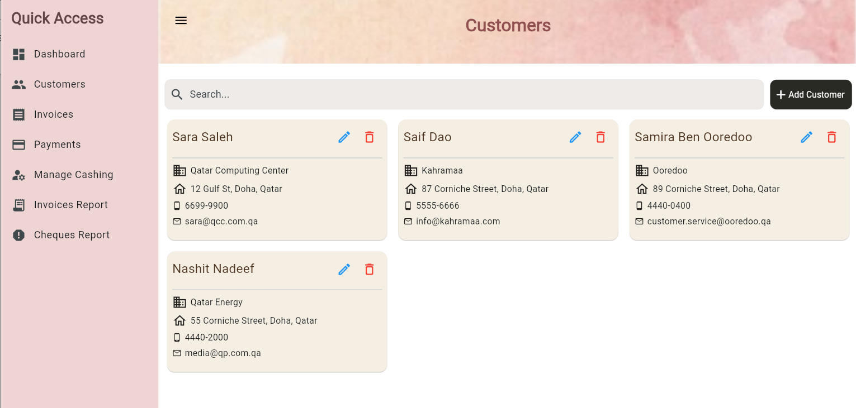

**When deleted I deletes all invoices associated with it**

* **Customer Search:**

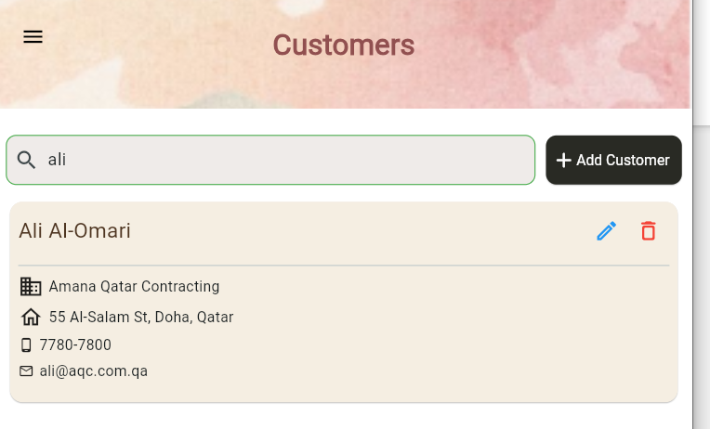

* **Customer Add:**

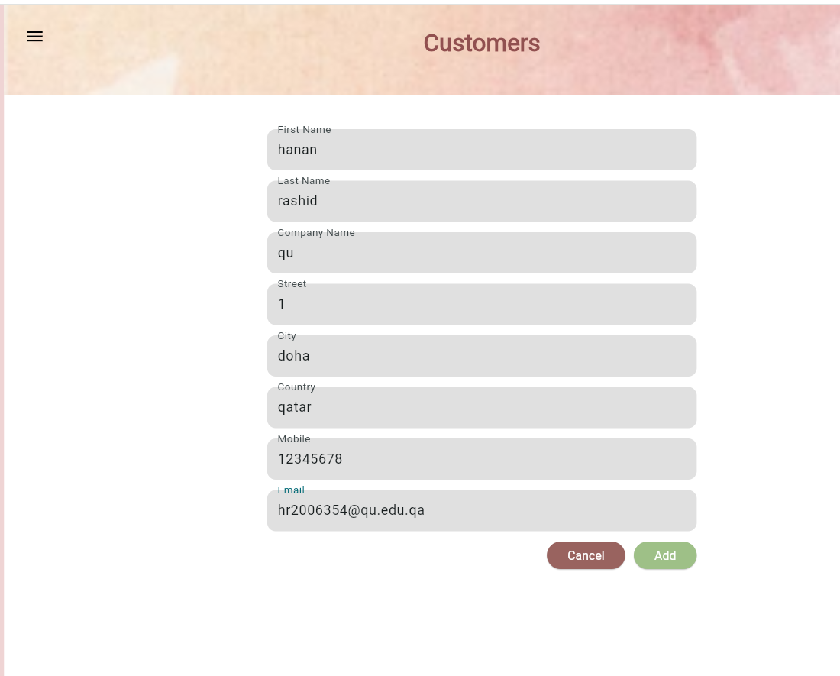

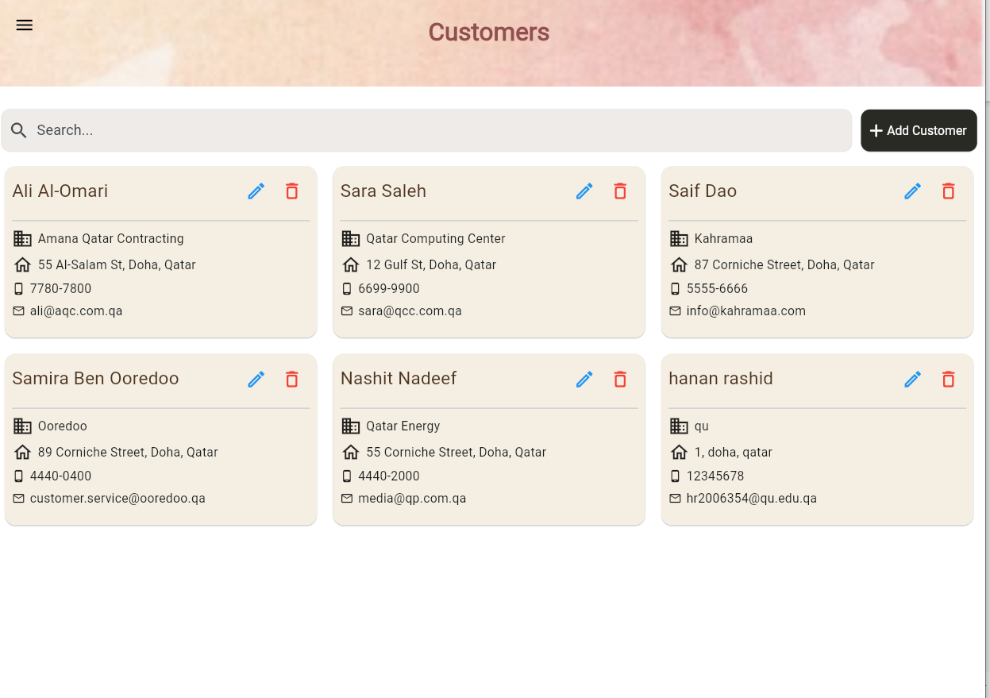

* **Customer Update:**

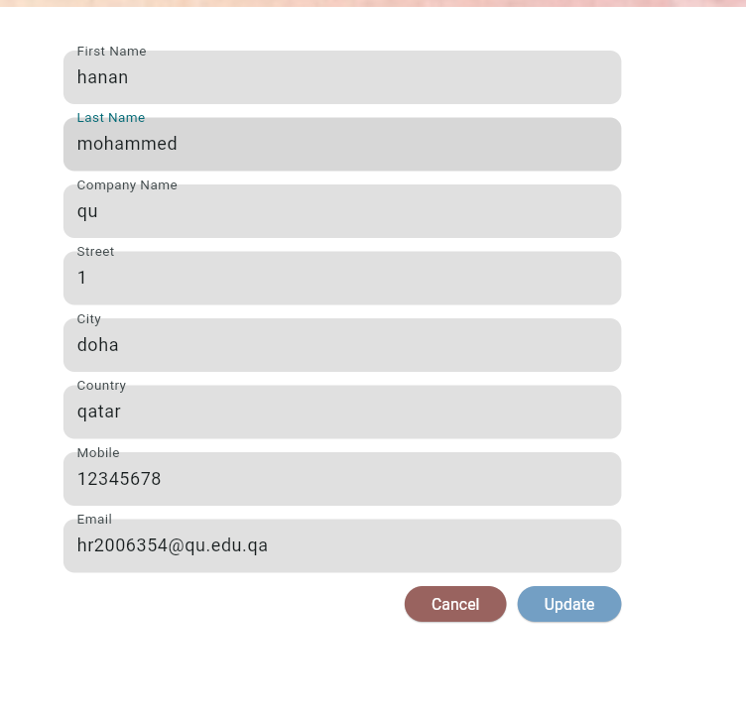

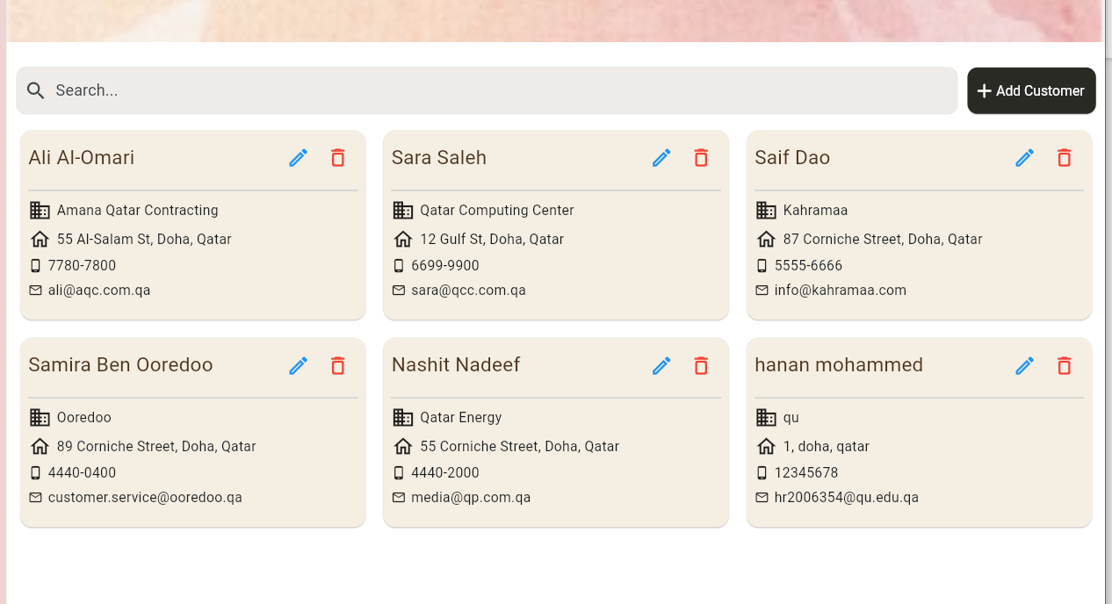

* **Invoices ( Responsive) :**

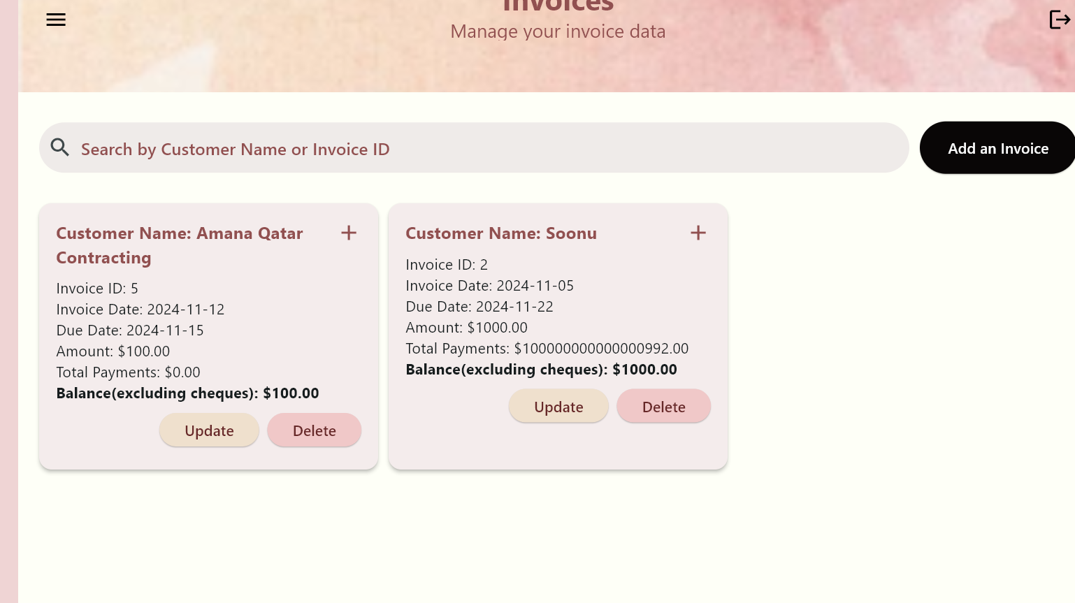

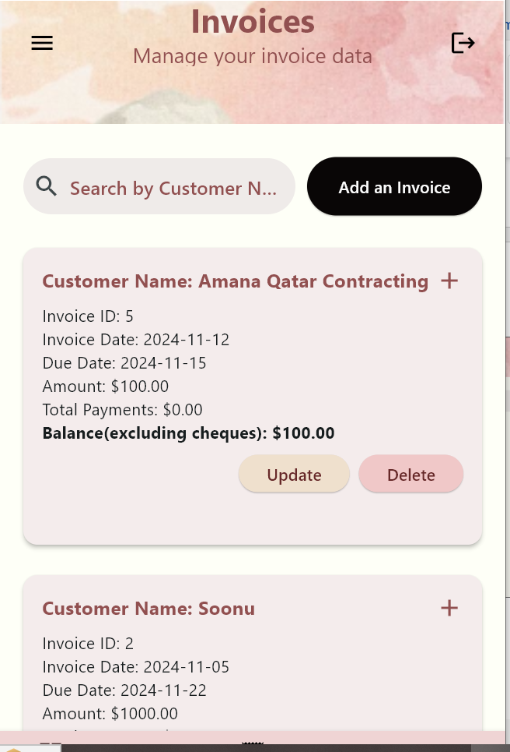

**For balance: only only computes balance excluding balance**

* **Delete invoice:**

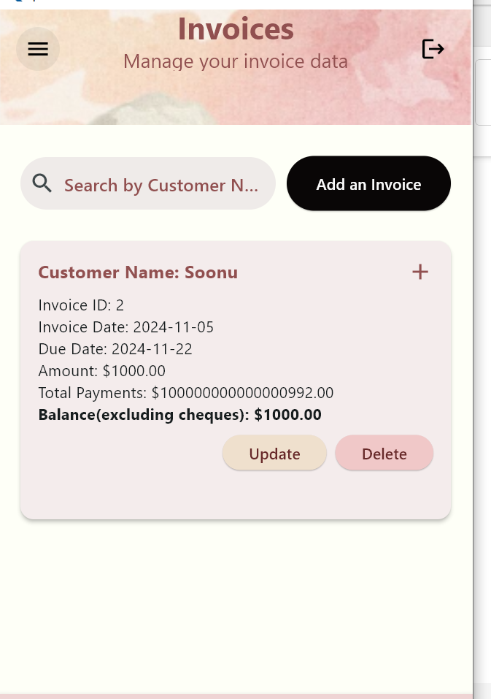

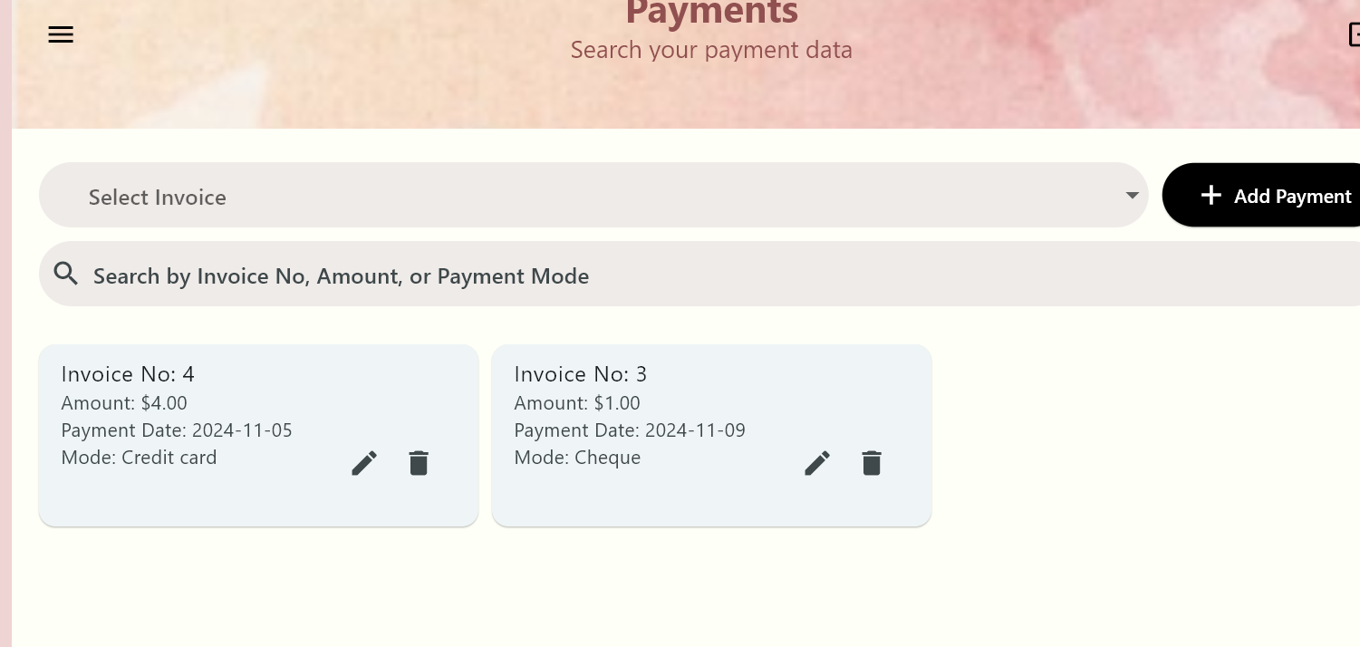

**It also deletes all payments associated with it**

* **Add invoice:**

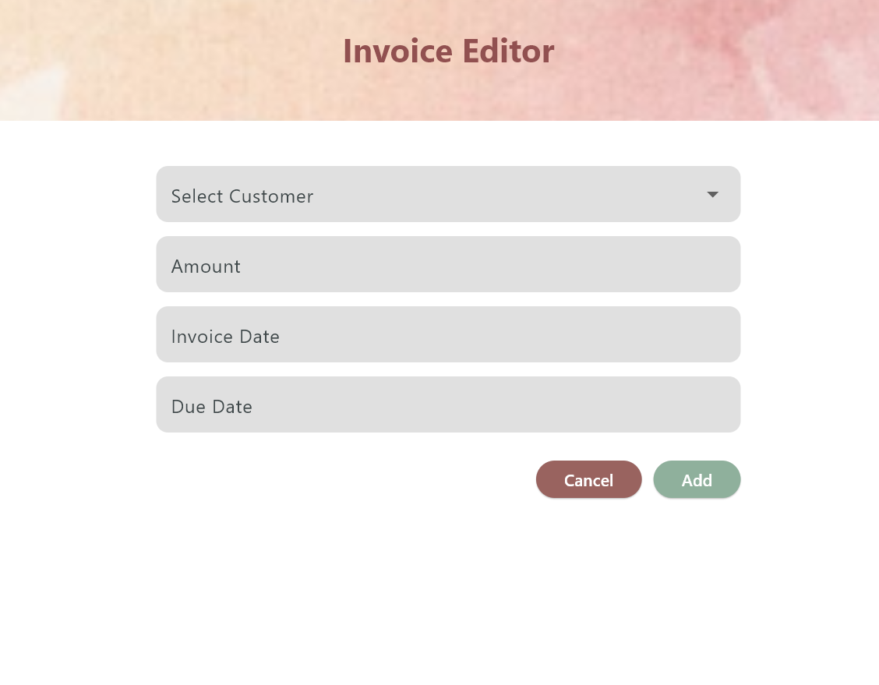

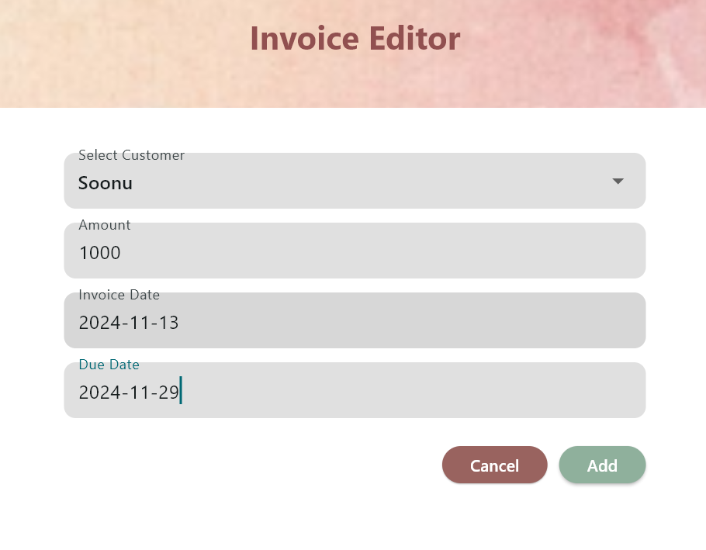

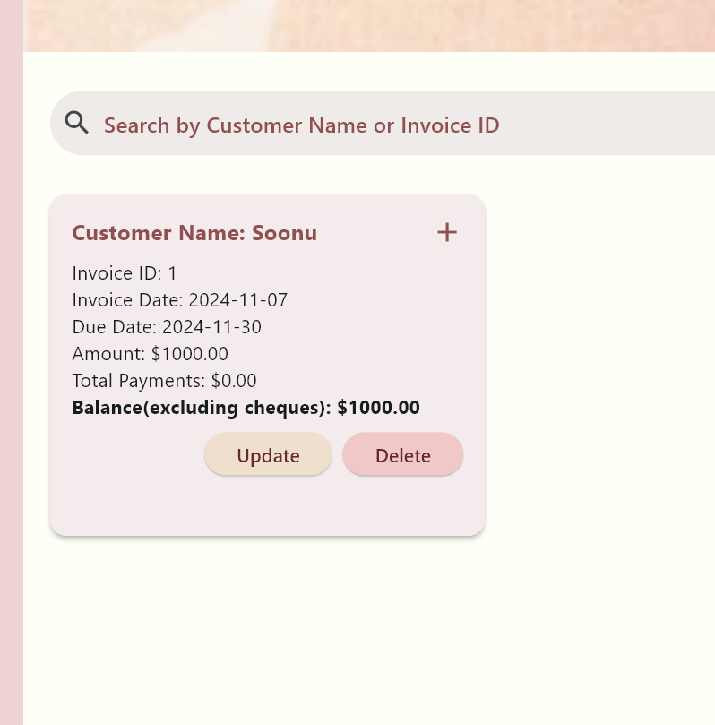

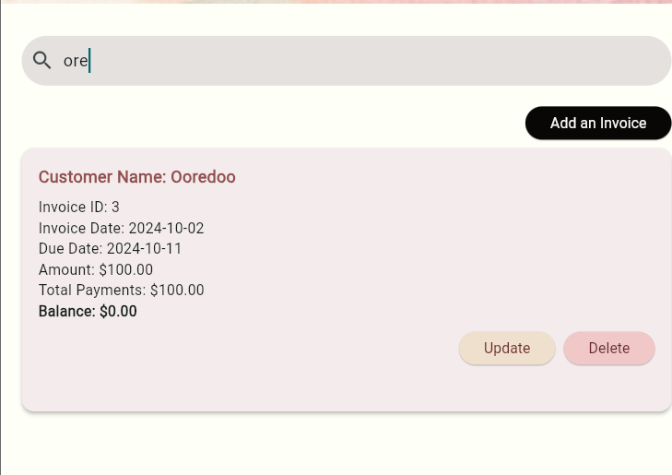

**-Update Invoice**

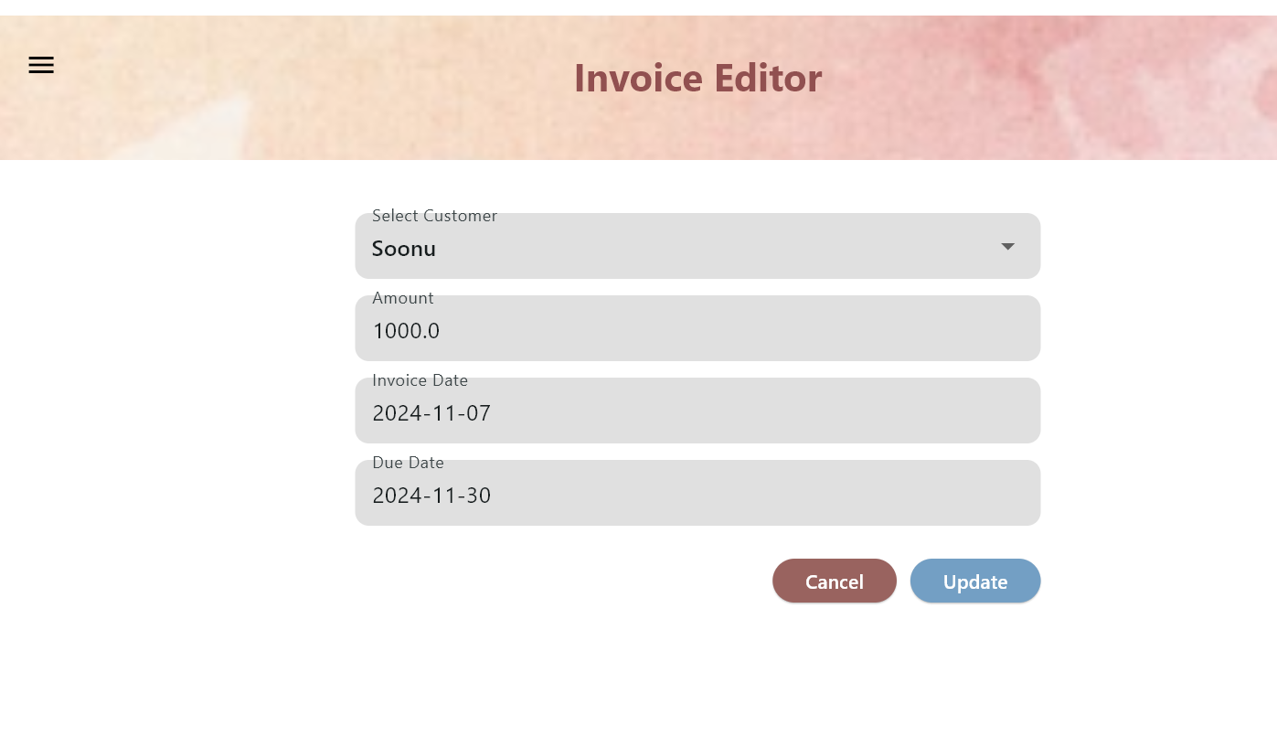

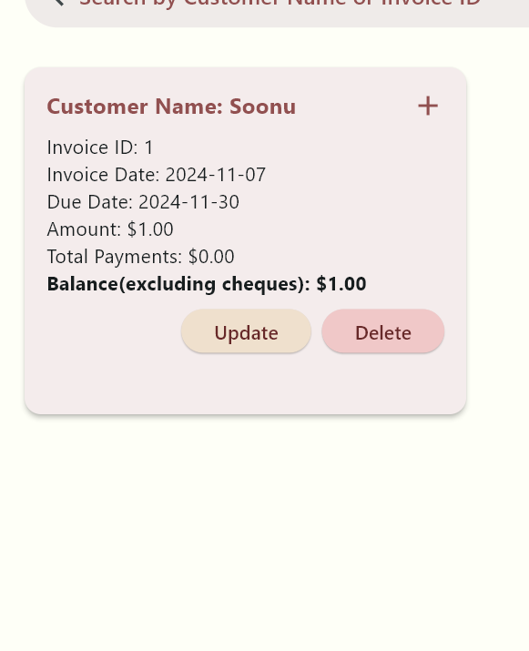

* **Enter payment for it**

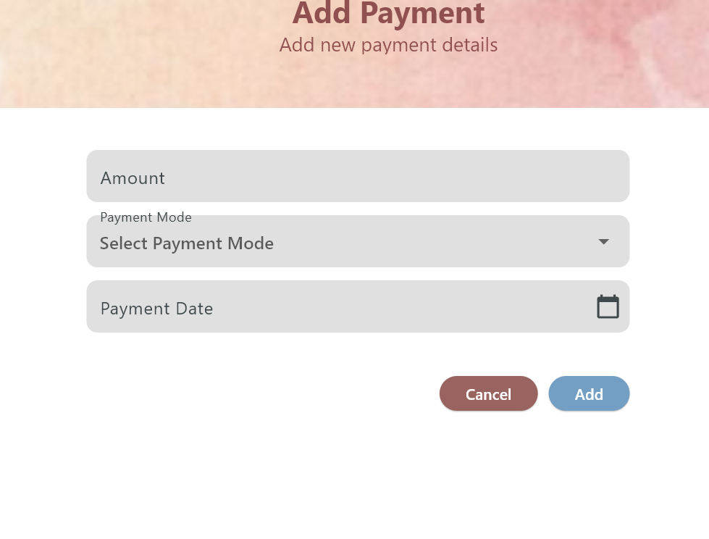

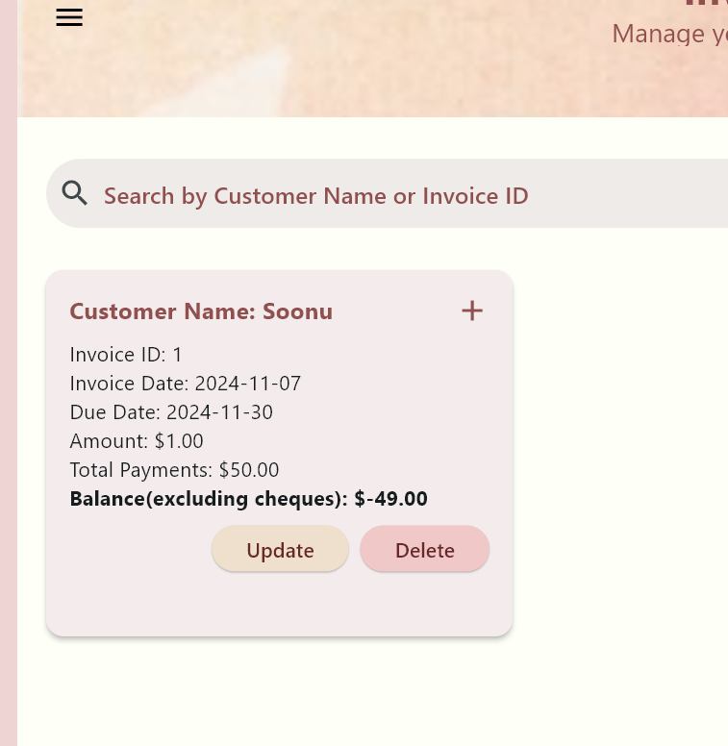

**-U6 - Manage Cashing Cheques**

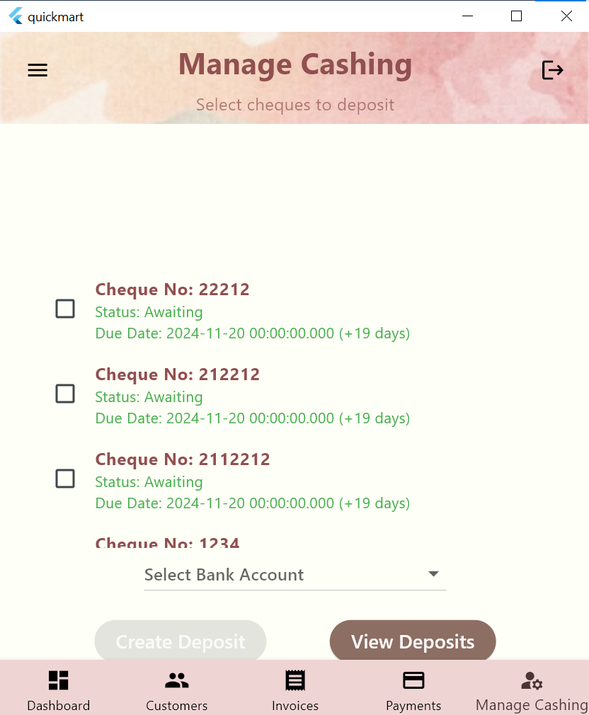

**The cheques no and status and due data are presented and cheques past their due date have their information written in red and the number of days past due are shown**

**You must check or multiple cheques and choose a bank account to deposit to before making a deposit**

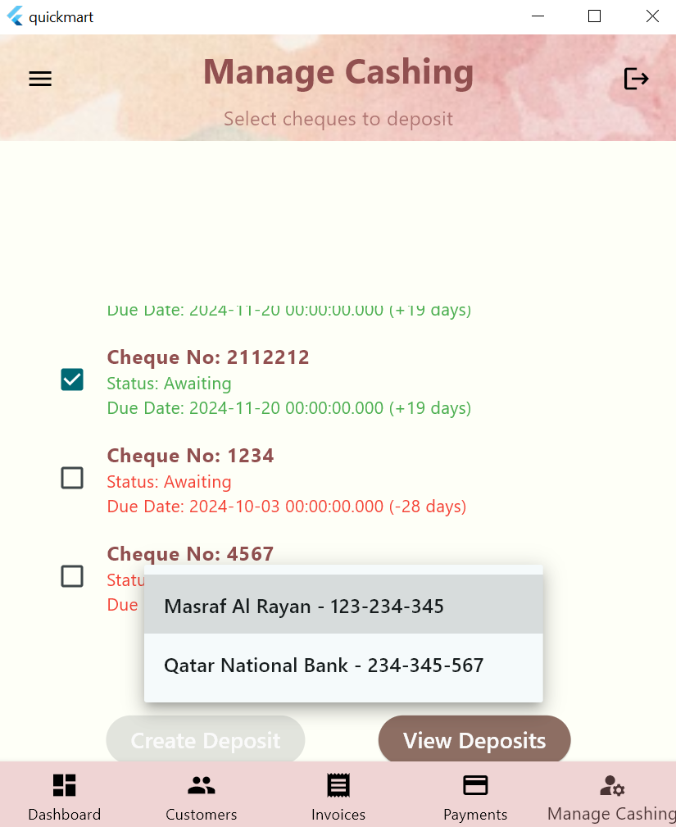

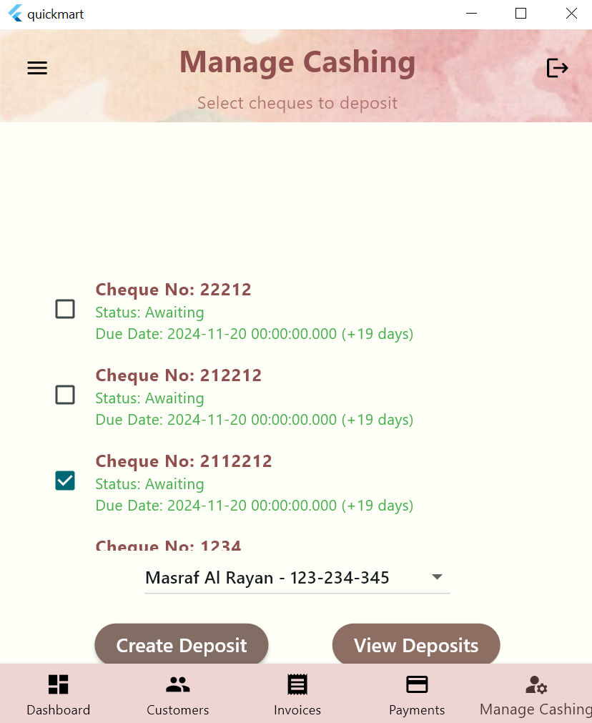

**Deposited cheque is greyed out and u can deposit multiple cheques at the same**

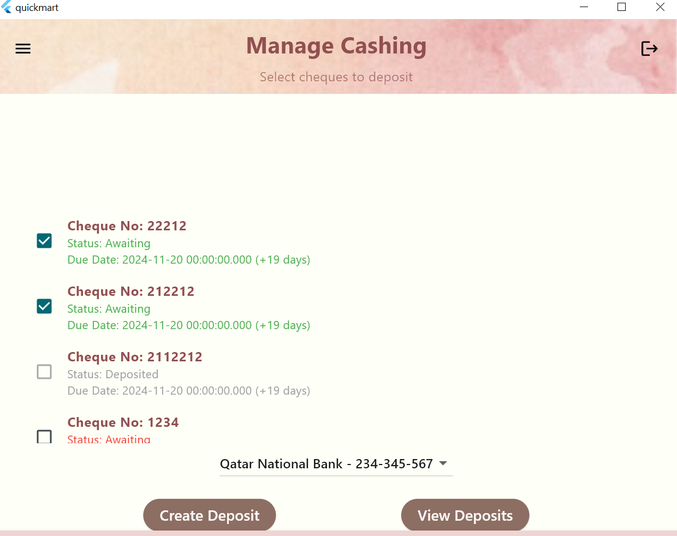

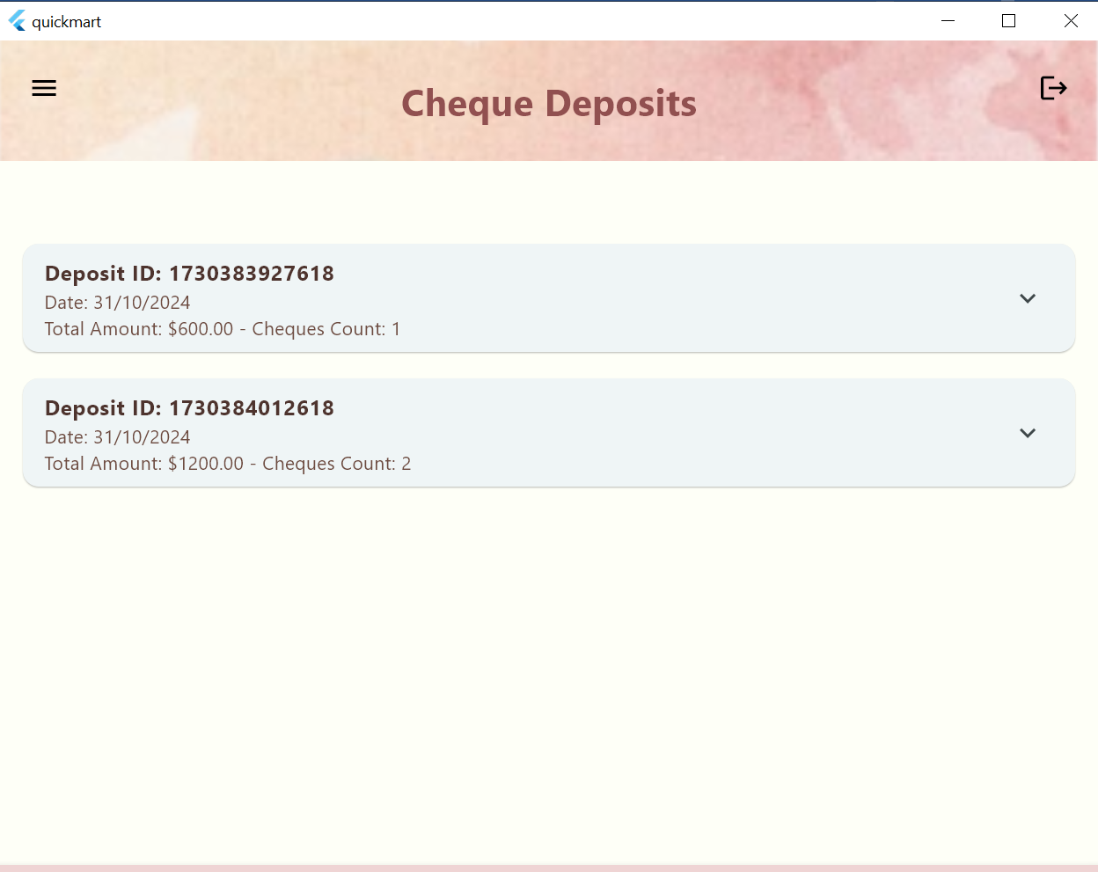

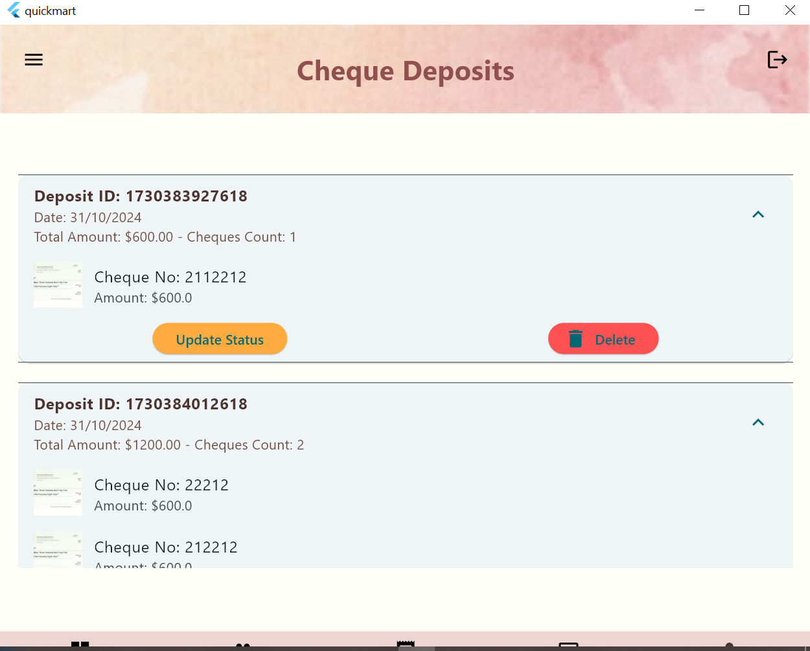

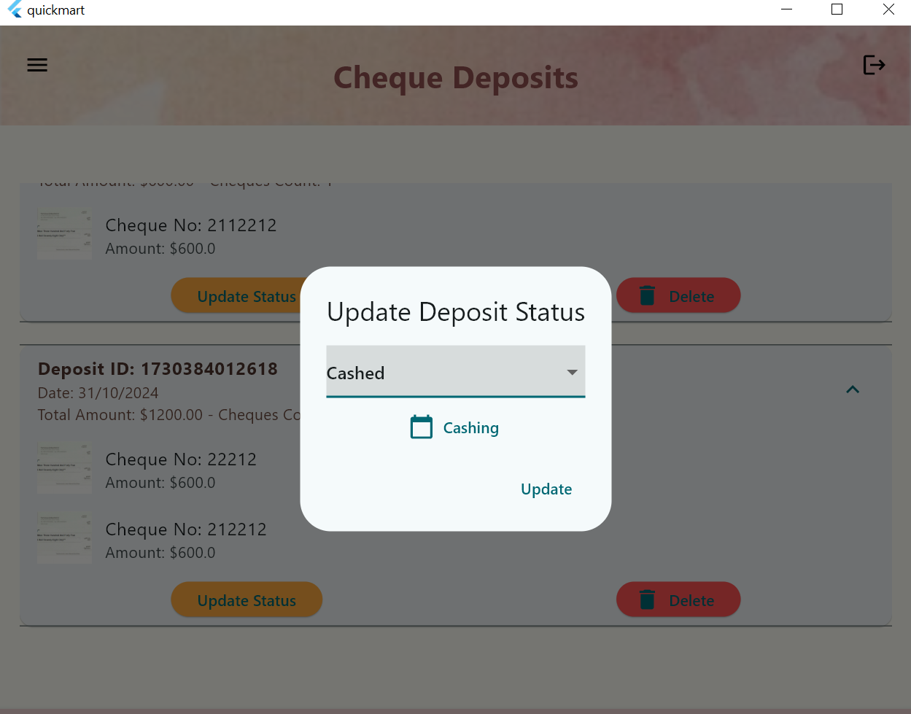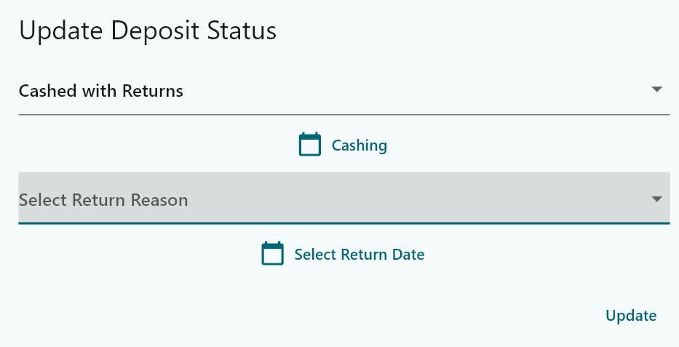

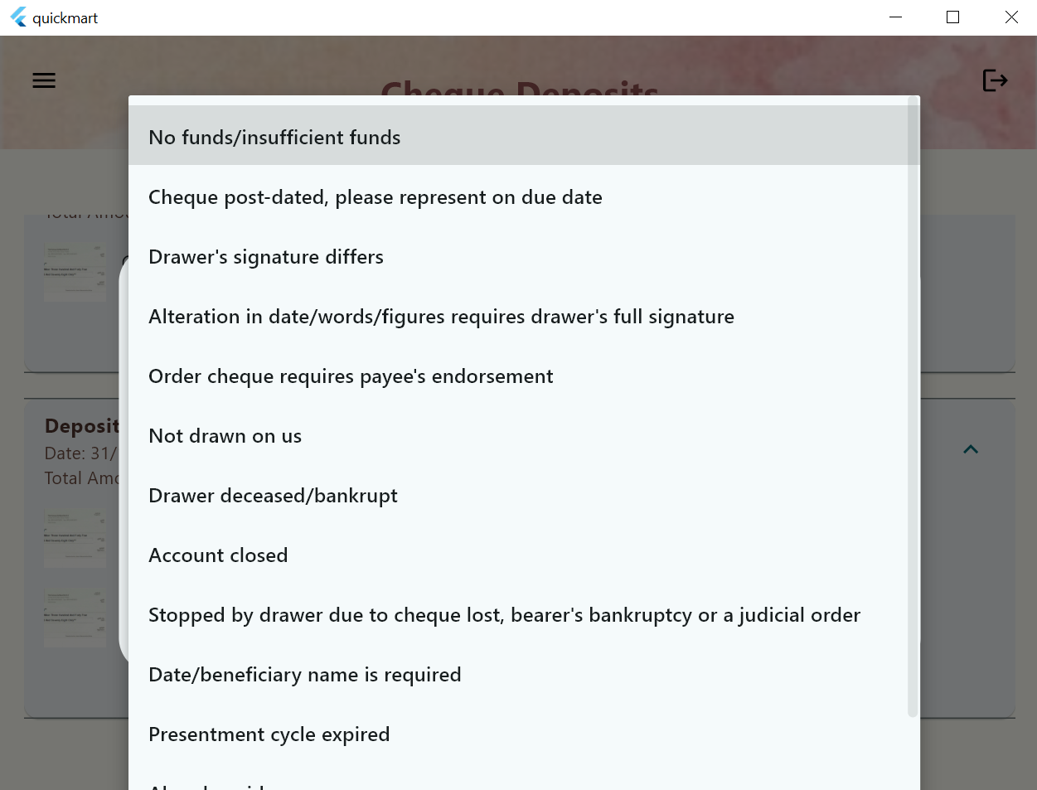

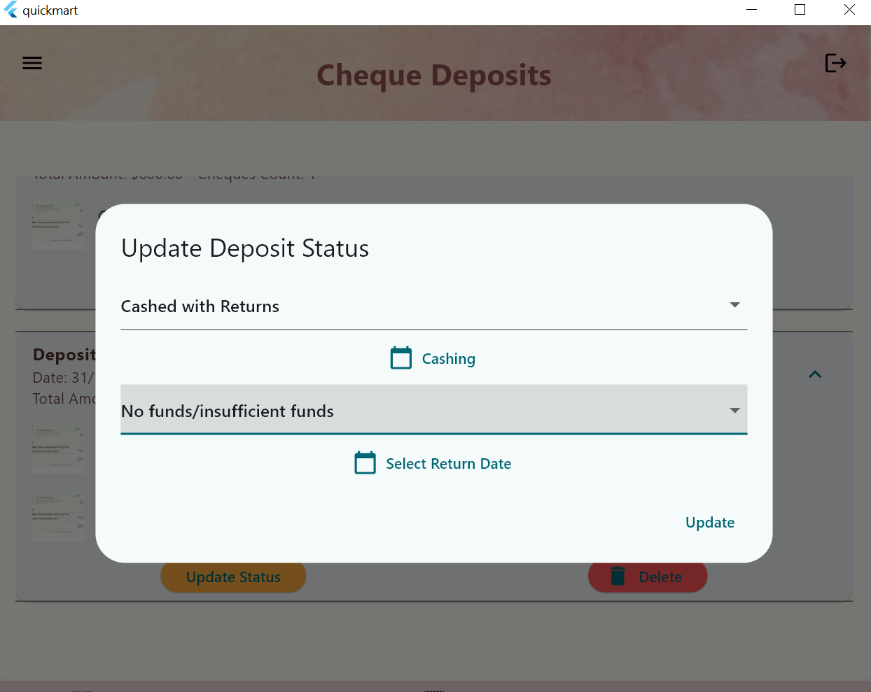

**Cheque report  
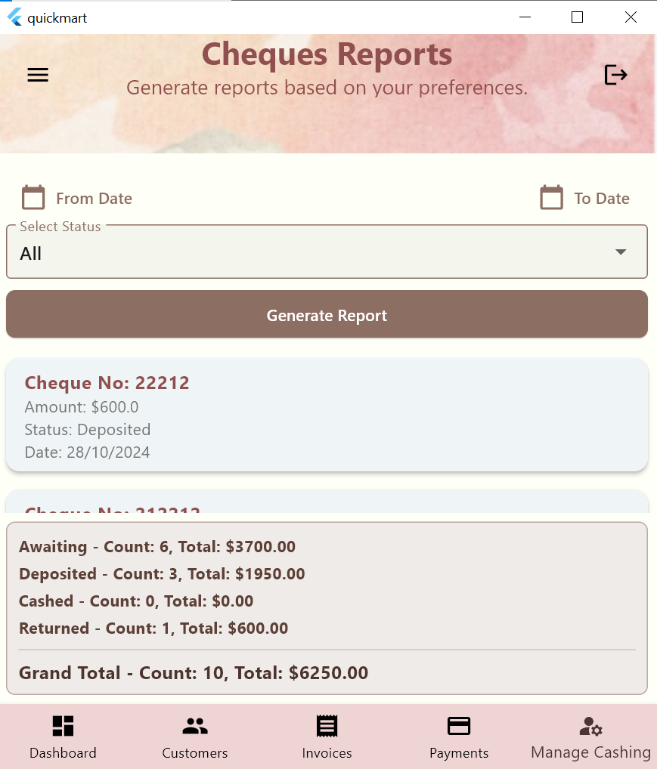**

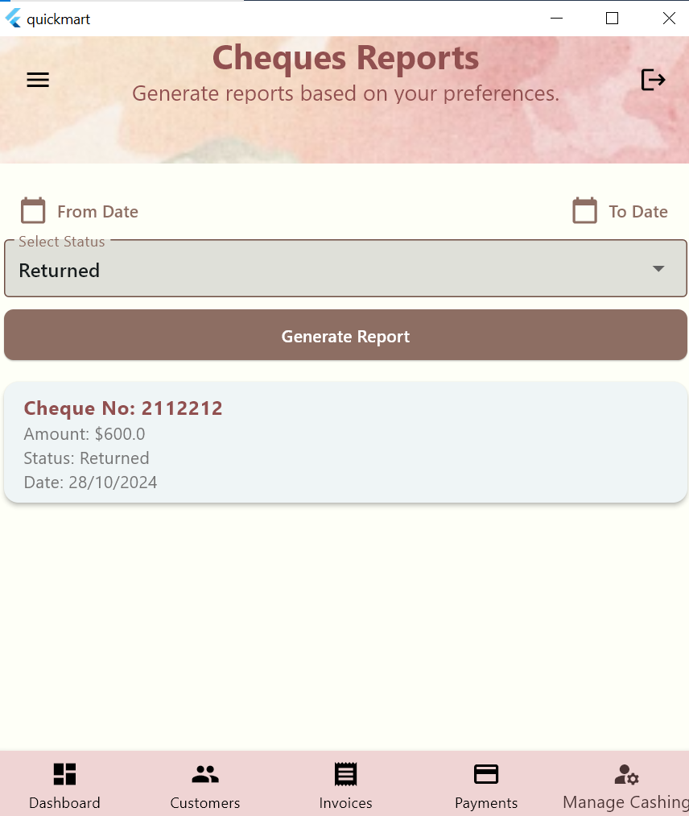

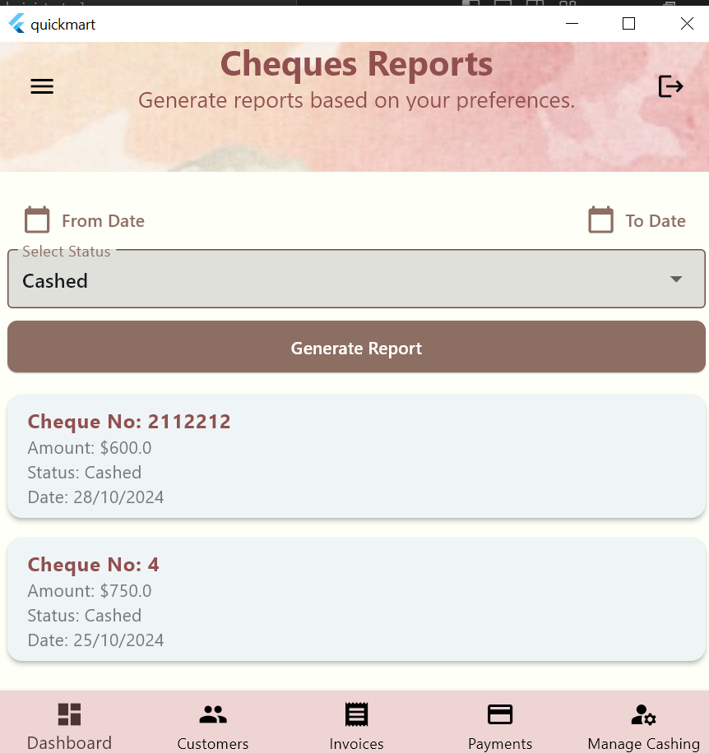

**Filtering using the from date   
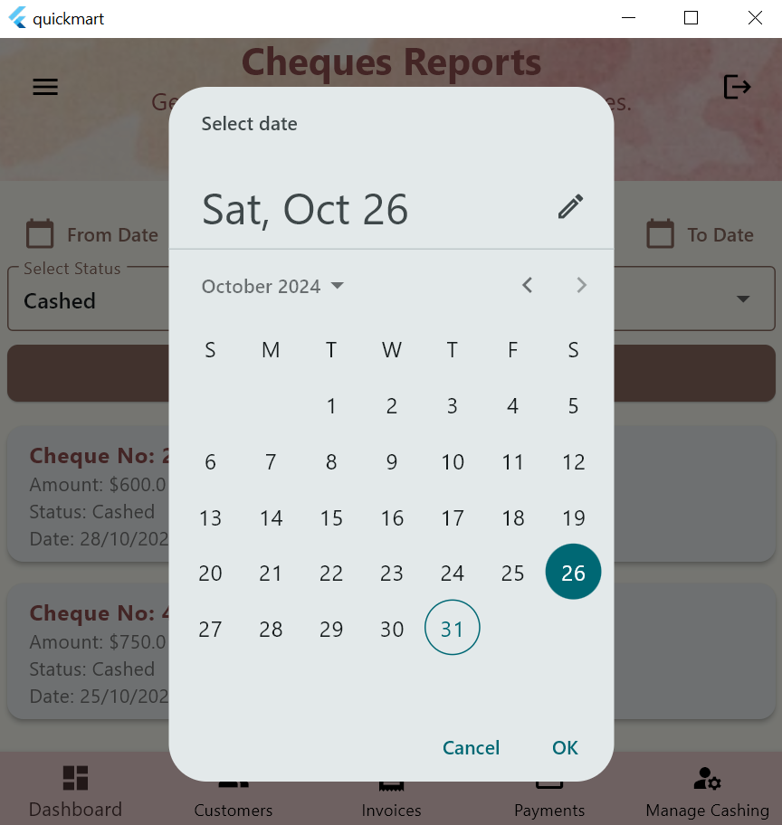**

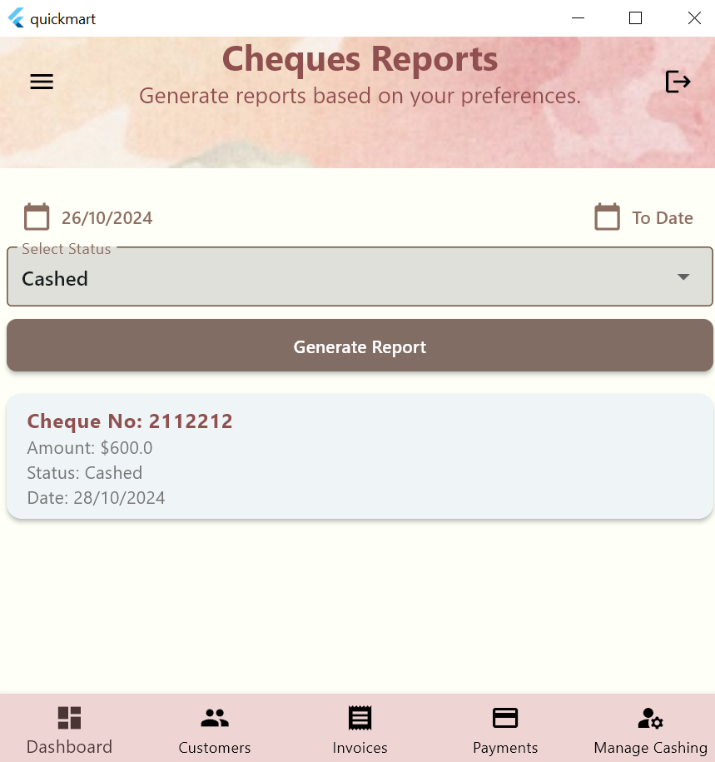

**The delete button deletes the cheque  
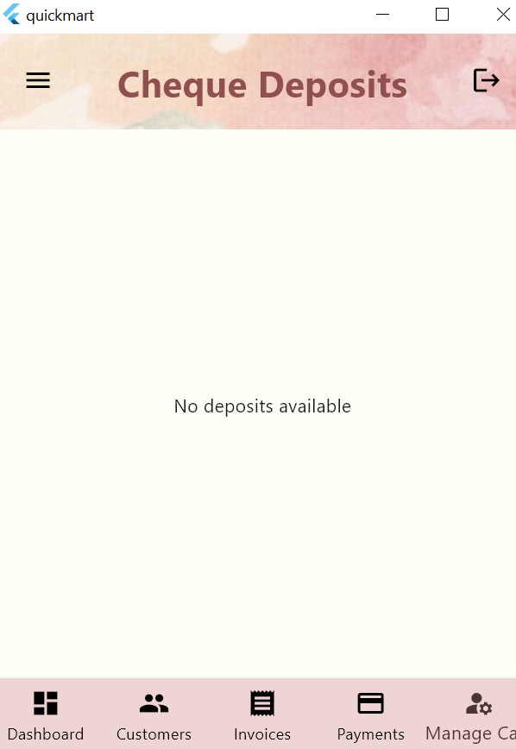**

**Invoice report**

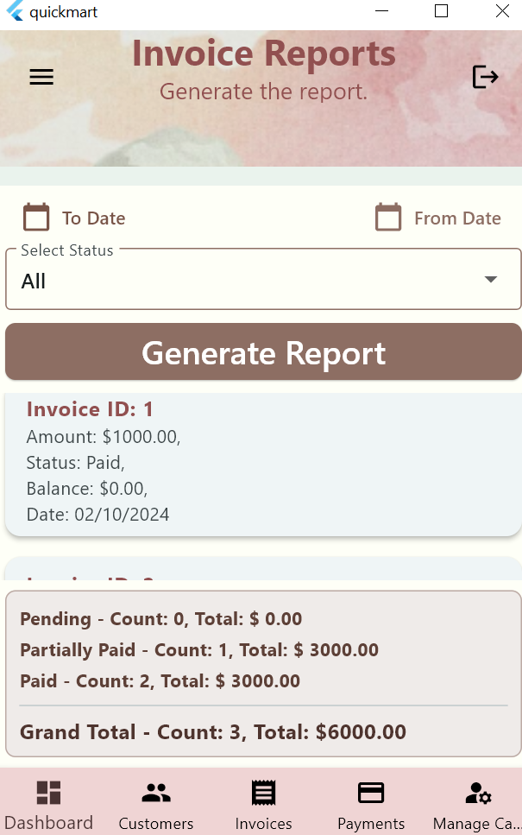

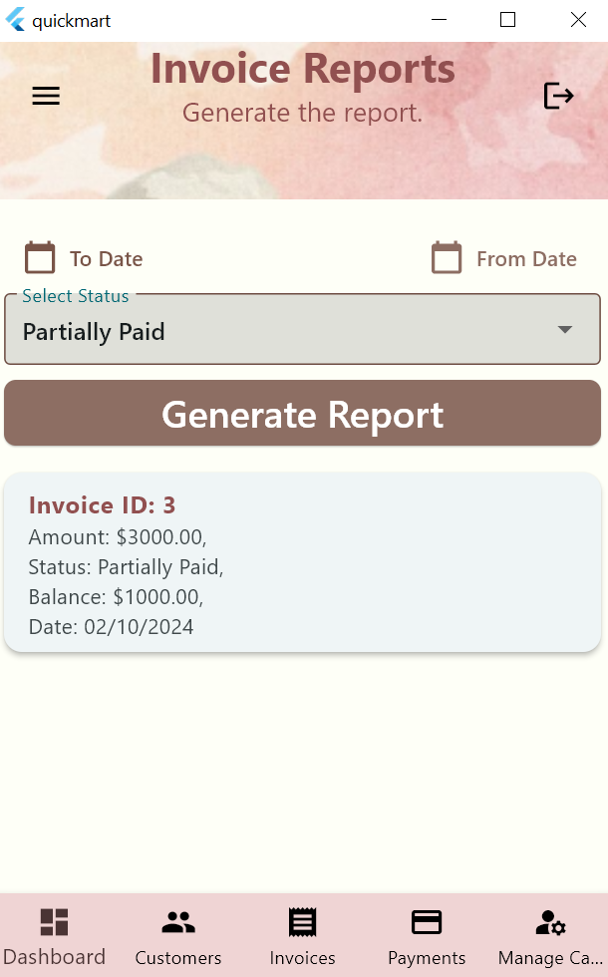

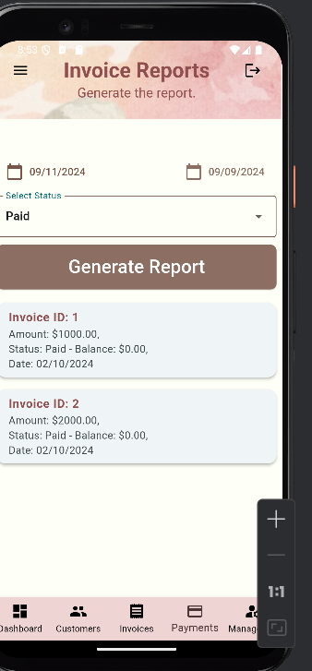

**Payment Screen**

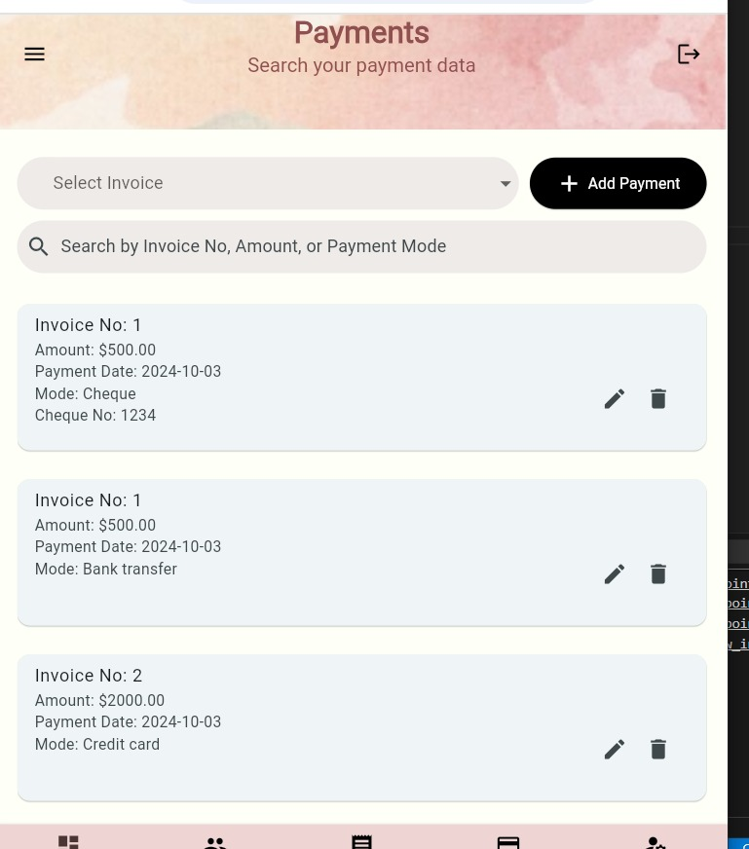

**Searching**

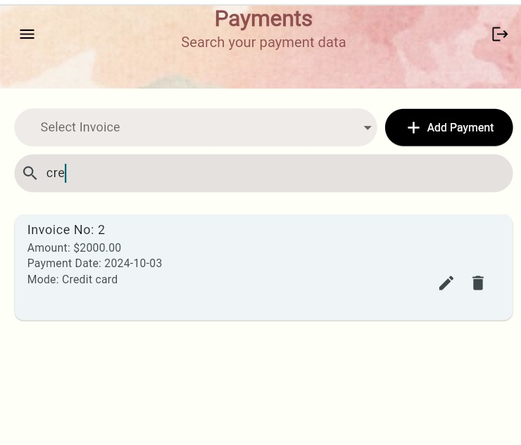

**Add payment only works when you select an invoice**

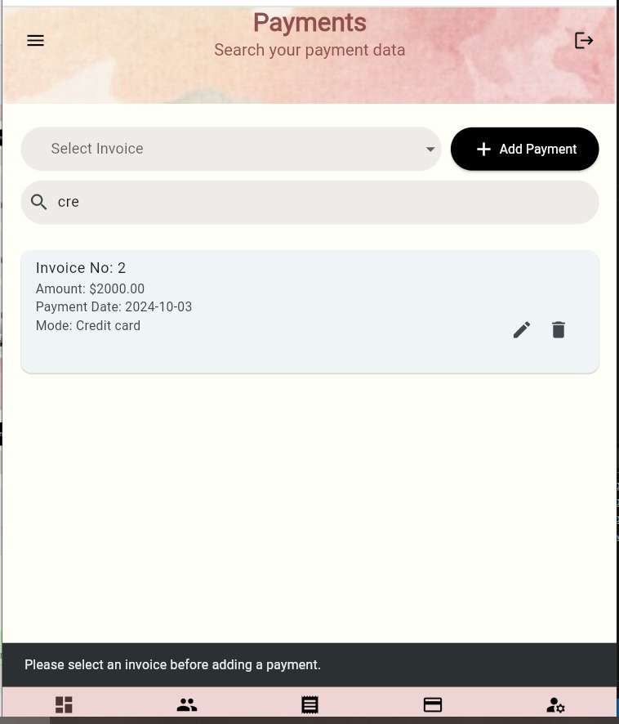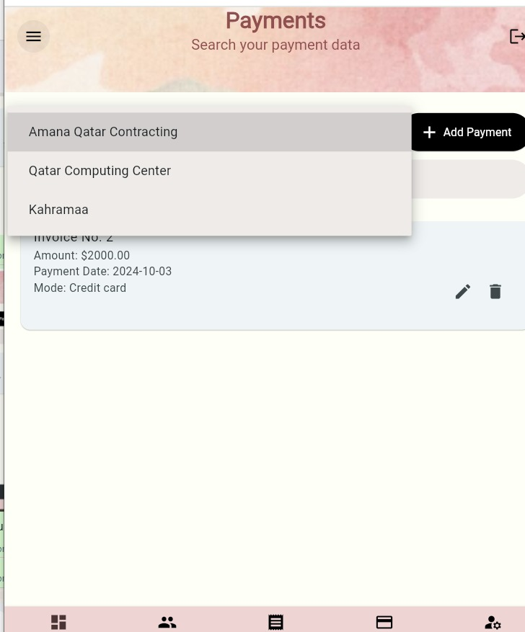

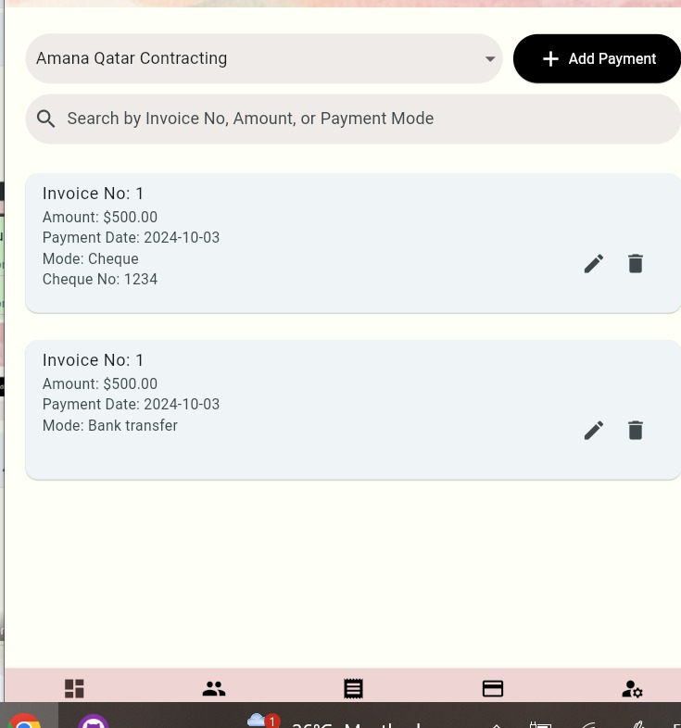

**Deleting an invoice**

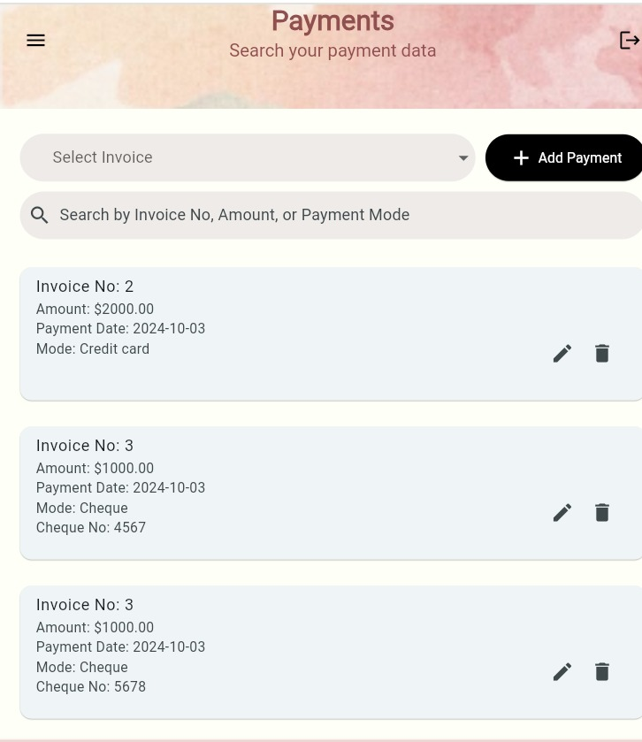

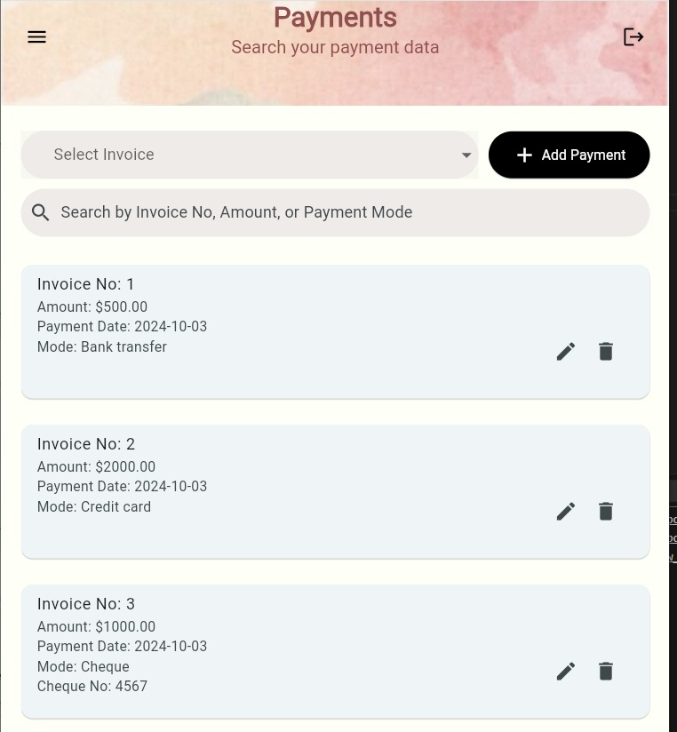

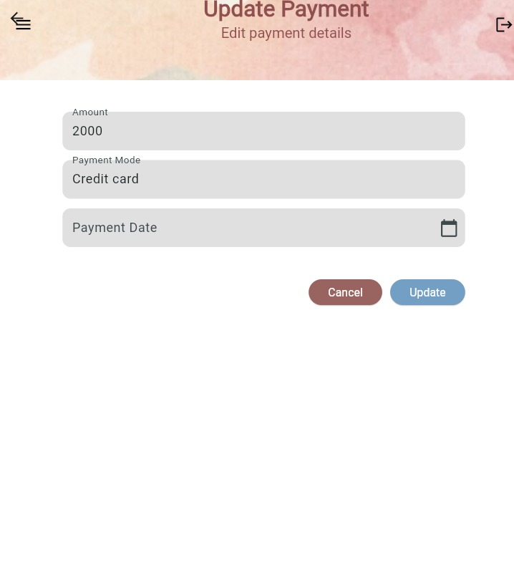

**Update invoice**

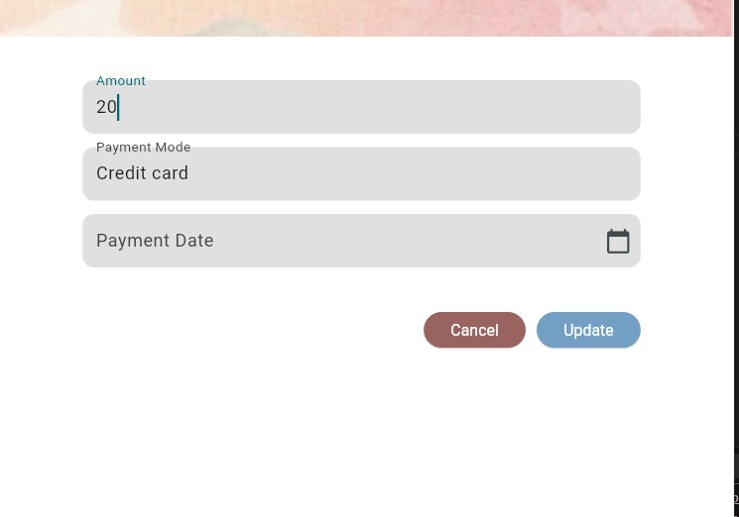

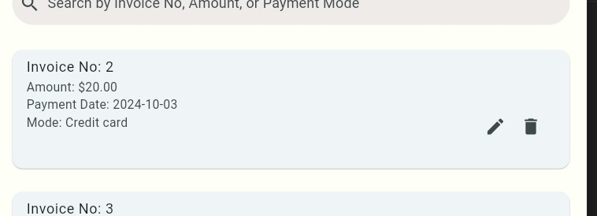

**cheque edit**

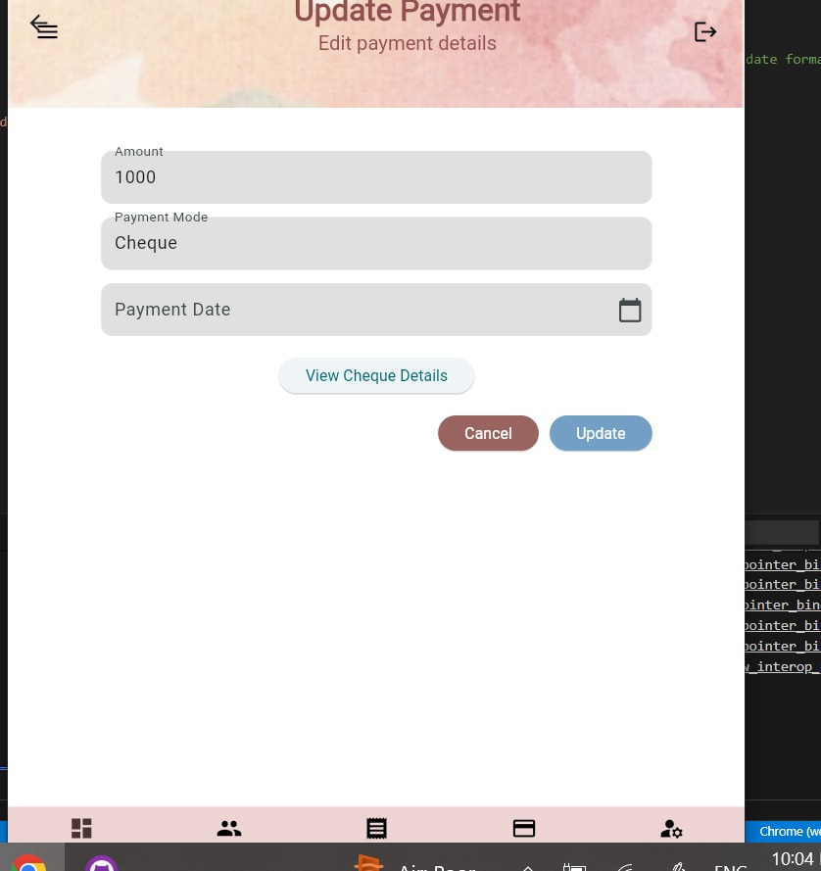

**Save changes**

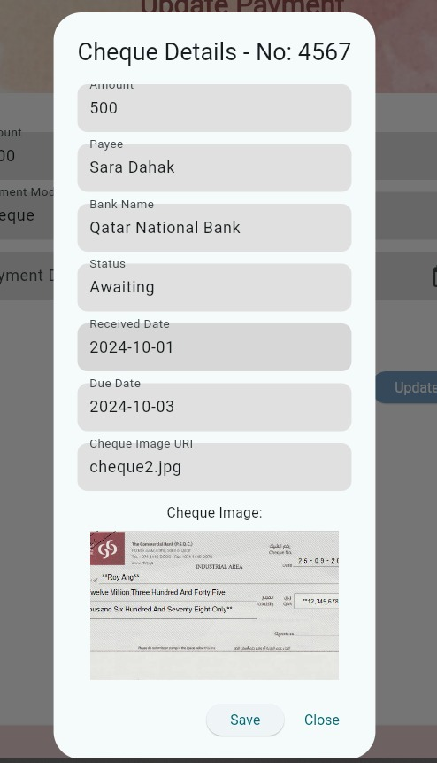

* **Add a Payment**

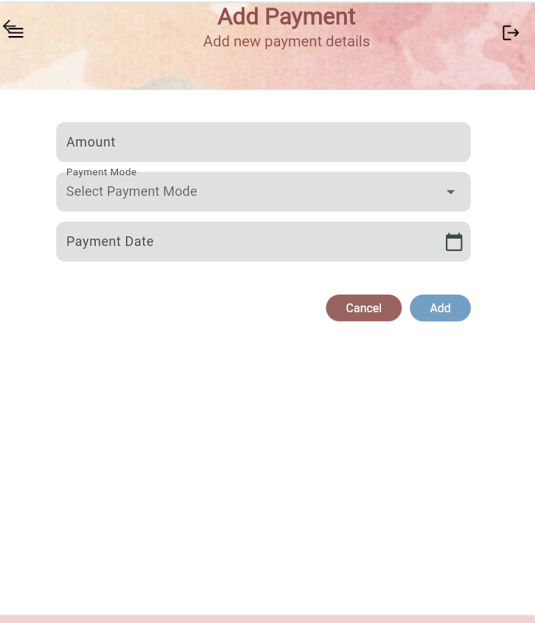

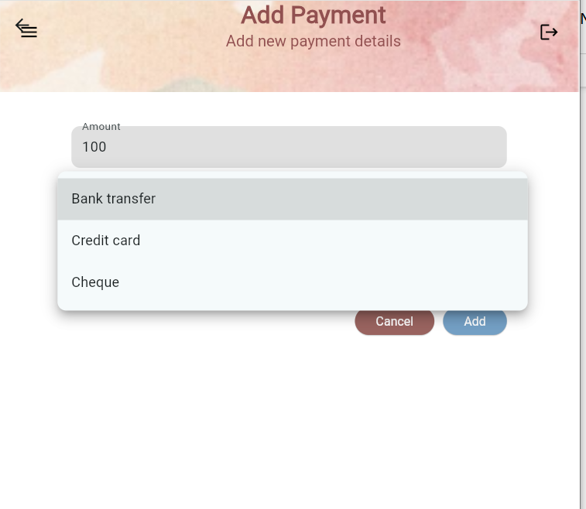

**When cheque is pressed it will give a dialog of cheque to fill**

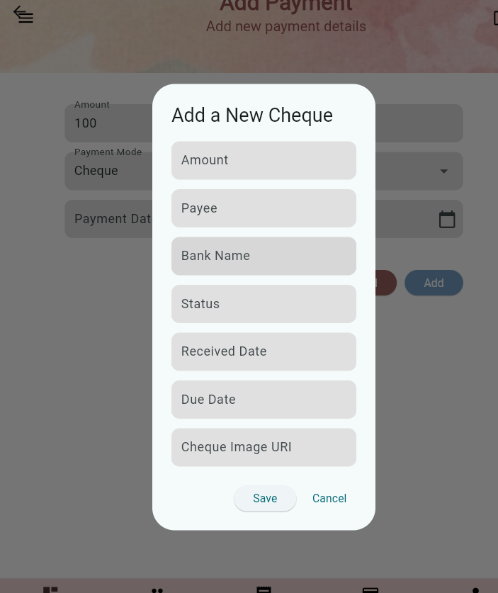

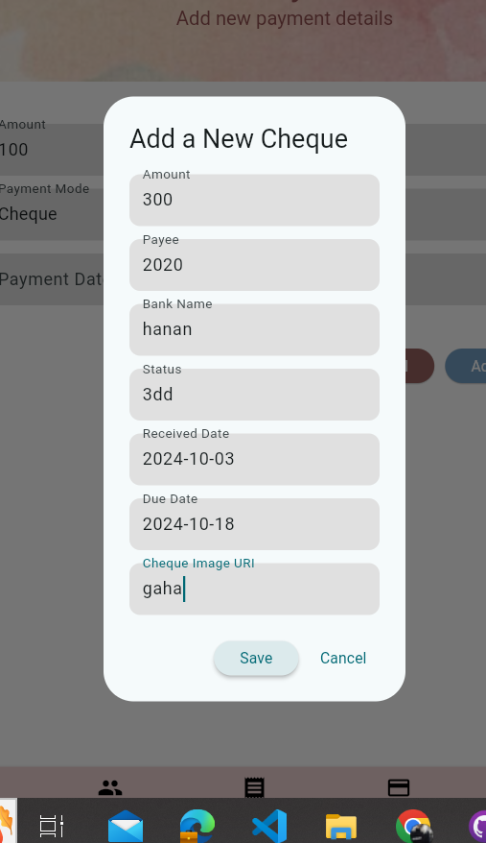

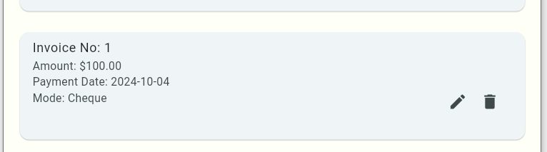

**Hanan alyafei / I have worked on the Login, customers use cases and for that I created the following files:**

**\*Under *models* folder :**

**address.dart**

**contact_details.dart**

**customer.dart**

**user.dart**

**\*Under *providers* folder:**

**customer_provider.dart**

**user_provider.dart**

**\*Under *repo* folder:**

**customers_repository.dart**

**user_repository.dart**

**\*Under *screens* folder:**

**customer_editor_screen.dart**

**customers_screen.dart**

**login_screen.dart**

**\*Under *widgets* folder:**

**add_customer.dart (add customer button)**

**customer_card.dart**

**error_alert.dart**

**Repository Classes Diagram**

